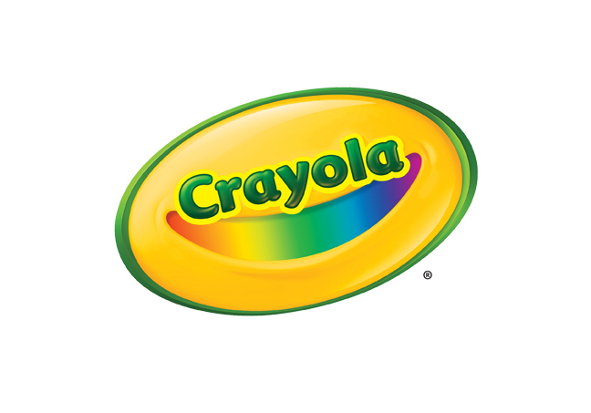**MEDIA CONTACTS**

Erika Merklinger

Crayola

eamerklinger@crayola.com

(610) 253-6272 ext. 4625

Alex Denti

Golin for Crayola

[adenti@golin.com](mailto:adenti@golin.com)

(212) 373-6022

**Crayola Marker Fact Sheets**

**CRAYOLA BROAD LINE MARKERS- 10 COUNT**

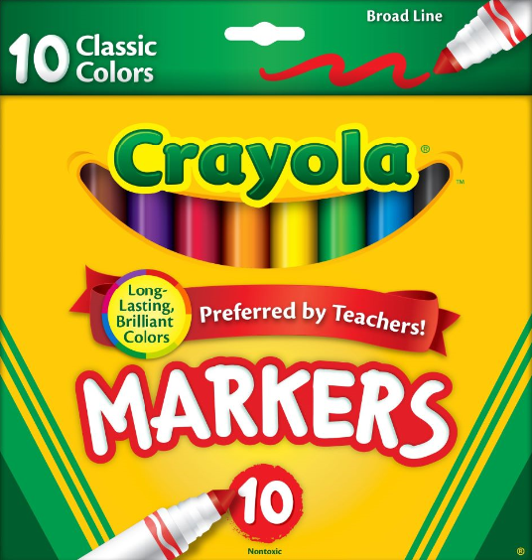

Crayola Classic Broad Line Markers are the classic, long-lasting, durable markers that many generations remember from childhood. They lay down brilliant color, yet won’t bleed through most paper. Crayola Markers are also preferred by teachers for all of their projects.

**BENEFITS**

* **Long-Lasting, Brilliant Colors:** This assortment of markers features 10 classic Crayola colors with high-quality, true-to-color ink that add bold, vibrant color to artwork, school assignments, and other creative projects
* **Ideal for Art and Classroom Projects:**  Feature sturdy conical tips that make them ideal for a variety of classroom and group art projects, especially coloring in large areas, drawing thin lines or dots

**TARGET AUDIENCE**

* Recommended for ages four and up

**WHERE TO BUY**

* Suggested Retail Price: $3.49
* Available at [Crayola.com](http://www.crayola.com/) and retailers nationwide

**Crayola Ultra-Clean Washable Markers- 10 Count**

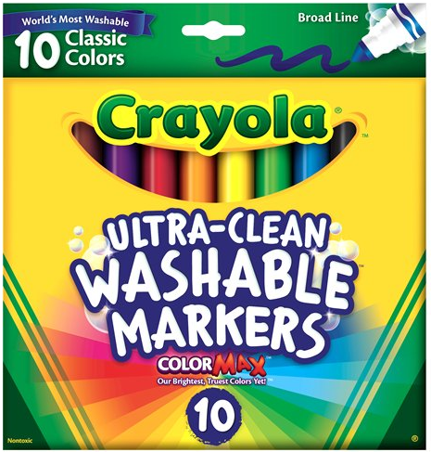

Crayola Ultra-Clean Washable Markers are formulated to provide brilliant color where you want it while washing easily where you don’t. Crayola’s classic markers now have an improved Ultra-Clean washable formula and come with two new bold colors.

**BENEFITS**

* **Crayola Color Max: True, Vibrant Colors:**  Provide artists with 10 Crayola colors that feature Color Max – Crayola’s brightest, truest colors yet
* **Superior Washability:** The world's most washable non-toxic markers now come in an improved Ultra-Clean formula that washes easily from skin, clothing, and common household surfaces – even painted walls
* **Versatile Tip Makes Thin and Thick Lines:** With its conical tip, these markers are perfect for coloring in large areas and drawing thin lines or dots; the markers lay down plenty of color and won't smudge or bleed through paper

**TARGET AUDIENCE**

* Recommended for ages four and up

**WHERE TO BUY**

* Suggested Retail Price: $5.99
* Available at [Crayola.com](http://www.crayola.com/) and retailers nationwide

**Crayola Washable Window Markers- 8 Count**

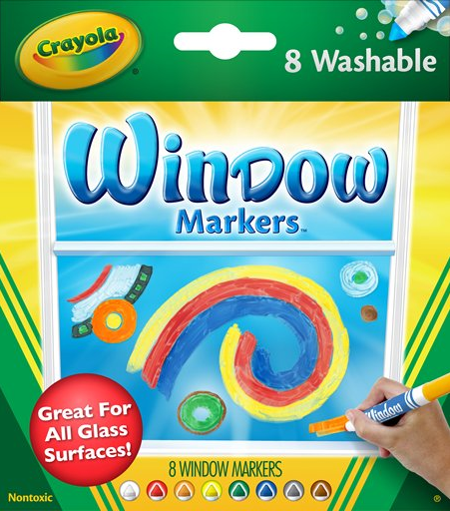

Crayola Washable Window Markers allow children to create fun and colorful designs on windows for holidays, birthdays, graduations, and other special occasions. Crayola Window Markers also work great on glass picture frames, mirrors, Mylar and more.

**BENEFITS**

* **Color Variety:** Eight different colors offer great color variety, allowing children’s imaginations to soar as they create custom designs on glass, mirrors, and more
* **Washability:** Washable formula allows colorful creations to be easily washed away from window surfaces

**TARGET AUDIENCE**

* Recommended for ages four and up

**WHERE TO BUY**

* Suggested Retail Price: $4.99
* Available at [Crayola.com](http://www.crayola.com/) and retailers nationwide

**Crayola Power Lines Washable Project Markers - 10 Count**

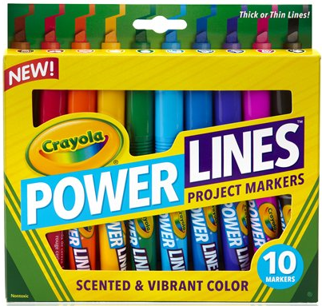

Crayola Power Lines Project Markers create rich, vibrant designs and with 10 different bold colors to choose from, children are able to create eye-catching drawings that stand out. The versatile tip can create thick or thin lines, so fine details and color can be added using the same marker.

**BENEFITS**

* **Ideal for School Projects:** Use Power Lines Markers for anything from school projects to arts and crafts. They work especially well on poster board, making them an ideal choice for creating visuals for science fairs and school presentations
* **Wedge Tip For Versatile Strokes:** Features a thick, wedge tip that’s perfect for creating both broad and fine lines; the wedge is especially helpful for coloring in large blocks of color and creating thick outlines for large letters
* **Sweet-Smelling Scents:** Sugary smells like Berry Fusion Blue and Crispy Marshmallow Black add an extra dimension of fun and creativity to kids' artwork
* **Ergonomically Designed:** Premium barrels and ridged grips that make them easy to control
* **Washable Ink Won’t Bleed Though**: Even though it's rich and juicy, the ink is washable, which means it comes off hands and most hard surfaces with simple soap and water. And it won't bleed through paper

**TARGET AUDIENCE**

* Recommended for ages four and up

**WHERE TO BUY**

* Suggested Retail Price: $8.99
* Available at [Crayola.com](http://www.crayola.com/) and retailers nationwide

**Crayola Fine Line Washable Super Tips- 50 Count**

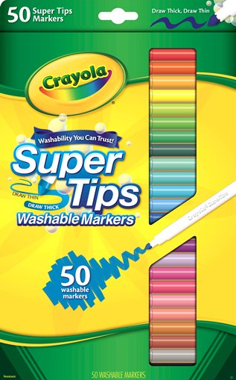

Crayola Washable Super Tips Markers feature a versatile tip that draws both thick and thin lines. Crayola's washable ink is specially formulated to easily wash from skin and most children's clothing.

**BENEFITS**

* **Vibrant Colors:** Each pack includes 50 classic colors, a staple for school projects and creative fun at home
* **Ideal for Detailed Creations:** Fine line markers with pointed tips allow for full control over designs, making them the perfect tool for more detailed artwork
* **Washability**: Easily washes from skin and most children's clothing

**TARGET AUDIENCE**

* Recommended for ages four and up

**WHERE TO BUY**

* Suggested Retail Price: $9.99
* Available at [Crayola.com](http://www.crayola.com/) and retailers nationwide

**ABOUT CRAYOLA**Crayola LLC, based in Easton, Pa. and a subsidiary of Hallmark Cards, Incorporated, is the worldwide leader in children's creative expression products. Known for the iconic Crayola Crayon first introduced in 1903, the Crayola brand has grown into a portfolio of innovative art tools, crafting activities and creativity toys that offer children innovative new ways to use color to create everything imaginable. Consumers can find the wide array of Crayola products in the "Crayola Aisle" at all major retailers.  For more information visit [www.crayola.com](http://www.crayola.com/) or join the community at [www.facebook.com/crayola](http://www.facebook.com/crayola).